Logistics
Event/meeting name
Location
Access
Contacts
Your engagement
Goals
Top stakeholders you will meet
Clothes

Messaging

Topic a
- Contributions
- Long-term investment, skilled jobs, and supplier partnerships that strengthen local and European competitiveness.
- Operational insight into how fragmented rules, duplicated reporting, and slow approvals affect day-to-day business activity.
- Willingness to pilot practical digital solutions with public authorities, especially for compliance, reporting, and cross-border processes.

- Asks
- Simpler, more predictable rules that are implemented consistently across member states.
- Digital-by-default administrative processes that reduce manual paperwork and repetitive filings.
- Clear guidance, realistic transition periods, and proportionate obligations for new legislative requirements.

Topic b
- Contributions
- Asks

Topic c
- Contributions
- Asks

Punchy messages menu
“Europe’s competitiveness depends on rules that are clear, proportionate, and easy to apply.”
“High standards and faster execution can and should go hand in hand.”
“Businesses invest more when policy is predictable, digital, and consistent across borders.”
“Administrative simplification is not deregulation - it is better regulation.”
“A strong Single Market should feel single in practice, not just on paper.”
“Digital public administration is one of the fastest ways to improve competitiveness.”
“Innovation thrives when regulation is workable, timely, and based on practical realities.”
“The most effective policy changes are often the ones that remove friction, duplication, and uncertainty.”
“Public-private dialogue works best when it focuses on concrete barriers and implementable fixes.”
“Europe can stay ambitious while making compliance easier to understand and easier to deliver.”

Stakeholders
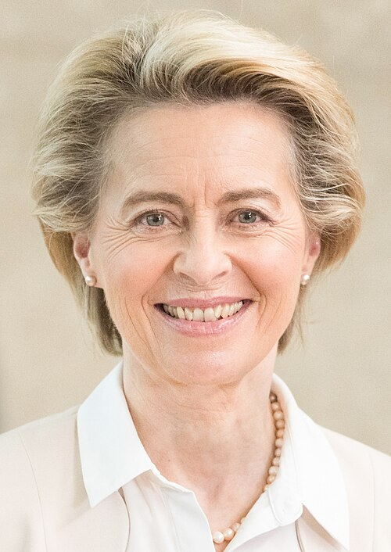 | Ursula von der Leyen - President, European Commission  - Website: commission.europa.eu/about/organisation/president_en  - Background: Medical doctor and German politician. President of the European Commission since 2019 and re-elected for a second mandate in 2024. Previously served as Germany's Federal Minister of Defence, Labour and Social Affairs, and Family Affairs.  - Relevance: Key decision-maker on EU competitiveness, industrial policy, Single Market implementation, digital policy, sustainability, and regulatory simplification. Highly relevant for discussions on EU policy priorities and business operating conditions.
Name, title, organisation
- LinkedIn/Website:
- Background:
- Relevance:
Name, title, organisation
- LinkedIn/Website:
- Background:
- Relevance:
Name, title, organisation
- LinkedIn/Website:
- Background:
- Relevance:

